**St. Francis Institute of Technology Borivli (West), Mumbai-400103**

**(Autonomous Institute)**

**Department of Information Technology**

**Academic Year:** 2024-25

**Class:** TE-ITA/B**Semester:** VI

**Subject:** Web Lab

**Experiment – 4: To Create a simple HTML “Hello World” Project using Angular Framework and learn to apply ng-controller, ng-model and expressions in AngularJS.**

1. **Aim:** To study angularJS
2. **Objectives:** Aim of this experiment is that, the students will be able

* To Install Angular
* To create simple application
* To understand general and core features of AngularJS

1. **Outcomes:** After study of this experiment, the students will be able 

* To write code using Angular and AngularJS.
* To initialize angularJS application data

1. **Prerequisite:** Knowledge of HTML, CSS, JAVASCRIPT, Typescript and any text editor.
2. **Requirements:** Personal Computer, Windows operating system, VSCode, TypeScript, Node, browser, Internet Connection, google doc.
3. **Pre-Experiment Exercise:**

**Brief Theory:** Angular vs AngularJS

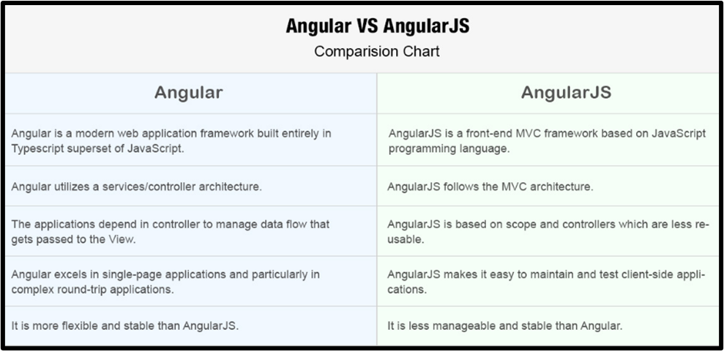

1. **Laboratory Exercise**
   * + 1. **Procedure:**

**a. Answer the following:**

* Define AngularJS?(in hand) (also Write explanation of highlighted points in hand)

| <div ng-app="myApp" ng-controller="myCtrl">  Name: <input ng-model="name">  </div>  <script>  var app = angular.module('myApp', []);  app.controller('myCtrl', function($scope) {  $scope.name = "your name";  });  </script> |
| --- |

**b**. **Attach screenshots:**

* Angular code and Output with your own comments and indentation.

1. **Post-Experiments Exercise**
2. **Extended Theory:**

Nil

1. **Questions:**

* Explain MVC architecture.(Draw and explain in hand)
* What is Angular JS expressions? Explain with example.(write in hand)
* What are different types of expressions? Explain.(write in hand)

1. **Conclusion:**(write in hand)

* Write what was performed in the experiment.
* Write the significance of the topic studied in the experiment.

1. **References:**
2. <https://riptutorial.com/ebook/angularjs>
3. Practical AngularJS by DinisCruz

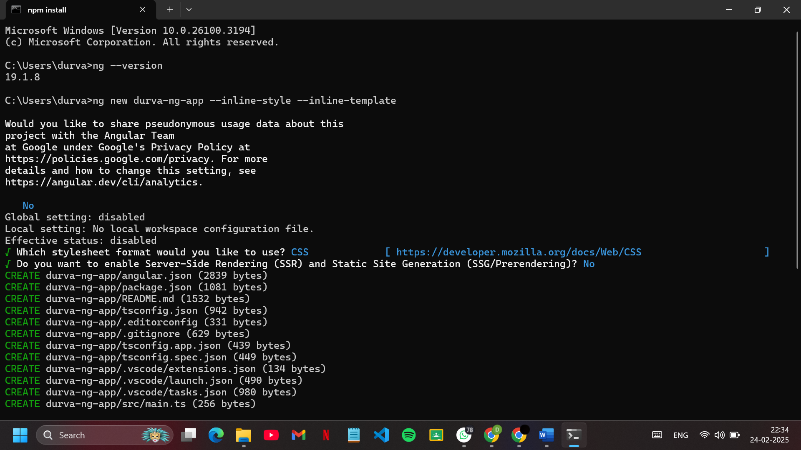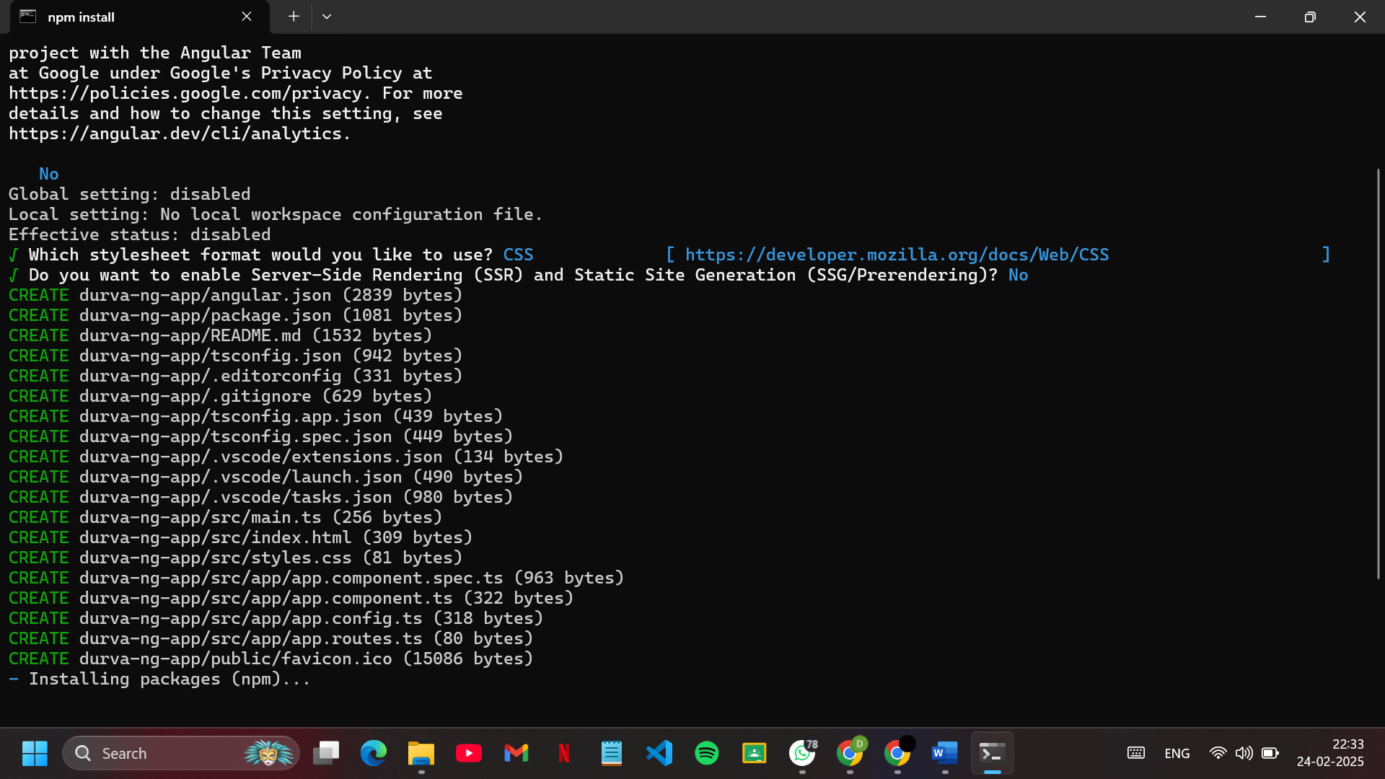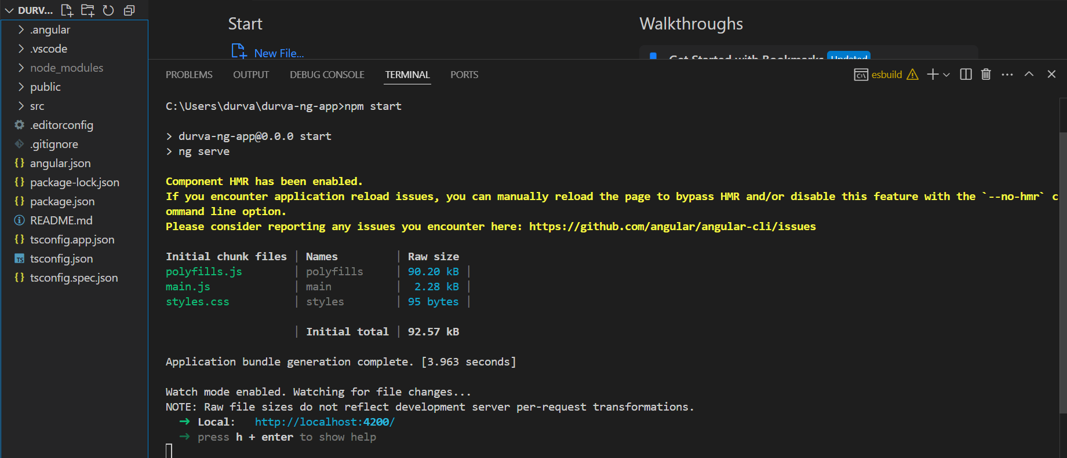

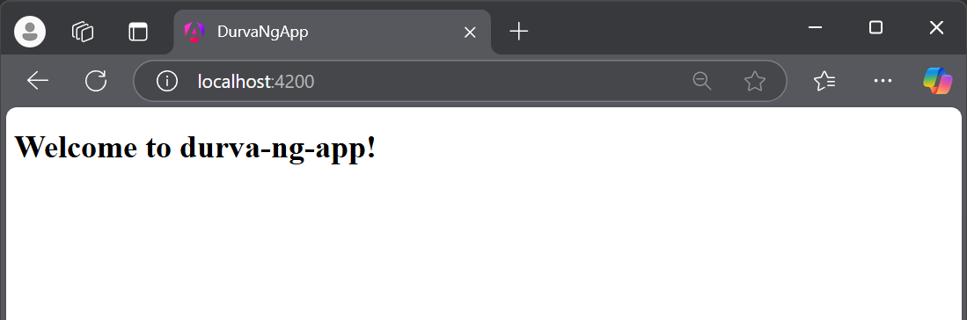

**CODE:**

<!DOCTYPE html>

<html lang="en">

<head>

<meta charset="utf-8">

<title>Durva</title>

<meta name="viewport" content="width=device-width, initial-scale=1">

<link rel="icon" type="image/x-icon" href="favicon.ico">

<script src="https://ajax.googleapis.com/ajax/libs/angularjs/1.8.2/angular.min.js"></script>

</head>

<body ng-app="libraryApp" ng-controller="LibraryController">

<h2>LIBRARY DETAILS</h2>

<table border="1">

<tr>

<th>Name of the Book</th>

<th>Book Number</th>

<th>Book Genre</th>

<th>Book Author</th>

</tr>

<tr ng-repeat="book in books">

<td>{{book.name}}</td>

<td>{{book.number}}</td>

<td>{{book.genre}}</td>

<td>{{book.author}}</td>

</tr>

</table>

<script src="app.js"></script>

</body>

</html>

**APP.JS**

// Define AngularJS module

var app = angular.module("libraryApp", []);

// Define a controller

app.controller("LibraryController", function($scope) {

// Book data array

$scope.books = [

{ name: "To Kill a Mockingbird", number: "B001", genre: "Fiction", author: "Harper Lee" },

{ name: "1984", number: "B002", genre: "Dystopian", author: "George Orwell" },

{ name: "Moby-Dick", number: "B003", genre: "Adventure", author: "Herman Melville" },

{ name: "The Great Gatsby", number: "B004", genre: "Classic", author: "F. Scott Fitzgerald" },

];

});

**OUTPUT:**